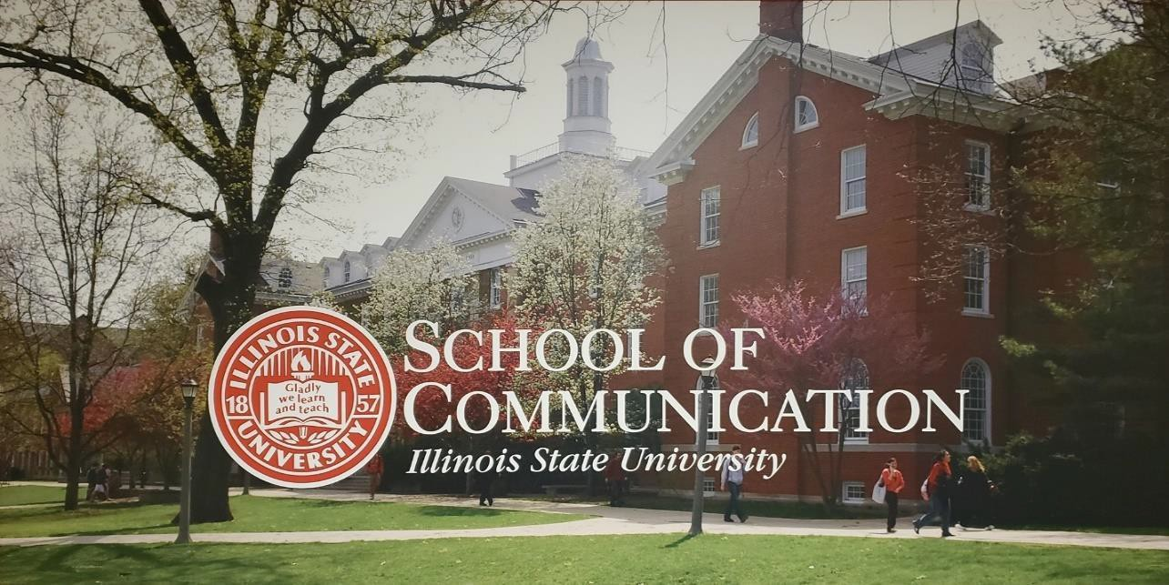

Master’s Program in Communication

Incoming Master’s Students Profiles Fall 2023

[Updated August 2023]

Janet Anani
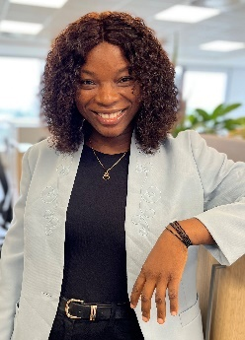
I am from Ghana, West Africa. I have a bachelor’s degree in Communication Studies, and I have keen interest in Public Relations and Organizational Communication. As an aspiring Strategic Communication Expert, I am confident ISU’s outstanding master’s program in communication will equip me with the requisite skills and knowledge to thrive in my career. I am thrilled to be part of the 2023 COM Grad Students to embark on this journey at ISU and the opportunity to work and connect with the excellent faculty members. Go Redbirds!!!!!

Daniel Sherrick Apambila
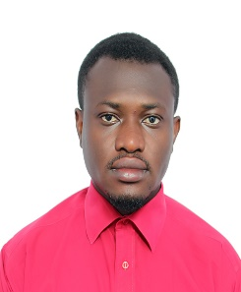
I am from Ghana and hold a Bachelor’s degree in Communication Studies with concentration in Public Relations from Ghana Institute of Journalism. It is with much joy that I will be joining the COM graduate cohort for Fall 2023. I expressed interest in pursuing a master’s degree in communication at Illinois State University’s School of Communication because the research support facility connects students’ with industry partnerships which I strappingly believe will help build my field experience as a Public Relations Professional. In my spare time, I enjoy playing table tennis and snooker.

Margaret Asare
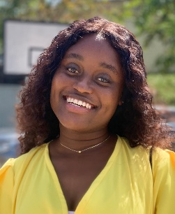
I was born and raised in Ghana, where I had the opportunity to pursue and obtain a Bachelor's degree in Communication Studies at the University of Cape Coast. The decision to embark on this academic journey was driven by my profound passion for Rhetoric Communication and its invaluable role in enhancing public relations and promoting businesses and brands. I am deeply committed to leveraging the power of effective communication to create impactful narratives and foster positive relationships. With a Master's in Communication, I aim to refine my skills in strategic and rhetoric communication, and digital media. By delving into advanced research methodologies, I seek to contribute fresh insights and innovative communication strategies to public relations and advertising.

Isaac Asare Kwakye
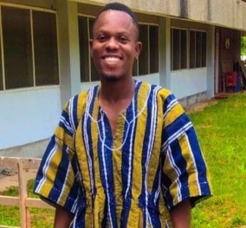
I am from the Eastern Region of Ghana. I graduated from the University of Cape Coast, Ghana where I earned a Bachelor of Arts Degree in (Communication Studies). My passion to obtain adequate knowledge and share the knowledge to enhance social transformation motivated me to take on a Teaching Assistantship duty with the Department of Communication, University of Cape Coast. I applied to ISU because the SoC trains one to be a well-rounded academic and to serve humanity thus, I believe it would be a great environment to put myself through rigorous training to gain analytical, logical, and problem-solving skills that will enable me to thrive in academia. I am more interested in the Public Relations and Interpersonal communication disciplines at ISU. In my free time, I talk to my family and friends.
Mark Ofosu Asirifi
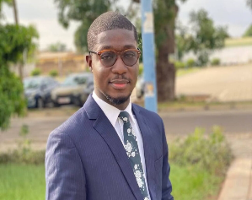
I am from Ghana and have a Bachelor's degree in Public Relations Management from the University of Professional Studies Accra. I chose Illinois State University for its award-winning graduate program in Communication, with its cutting-edge curriculum in developing communication strategies to solve problems affecting society, where my area of focus will be in Public Relations. The program's integration of theory, research collaboration, and professional development through faculty-student mentorship and collaboration with industry experts makes it a perfect fit for my career advancement. My career goal is to work as a communication consultant for UNICEF Ghana, contributing to national policies through communication strategies to combat female genital mutilation, vaccine hesitancy, health misinformation, and outdated cultural norms that violate women's human rights. I enjoy painting, classical music, history, writing blogs , taking part in volunteering activities and leadership roles .

Yasmin Carrillo
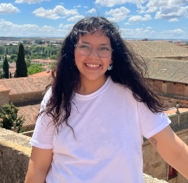
I graduated from Illinois State University this past May with my bachelor’s in journalism and political science. I also minored in sociology and Spanish. I was born and raised in Rockford, IL, about two hours north of BloNo. The communication discipline area I am interested in is rhetoric when it pertains to mis/disinformation in media in regard to politics. Fun fact, I work for the student accounts office on campus. I also have a background in financial aid and am passionate about college affordability and working with college students in general. I hope to work in higher education post-graduation and along the way obtain my Ph. D and teach at the university level. I love reading, the farmers market, and matcha lattes.

Gabrielle Crothers
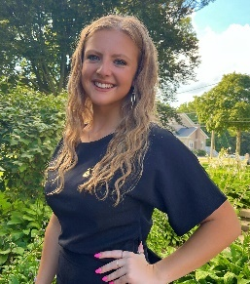
I am originally from Washington, IL but attended and graduated from Monmouth College in Monmouth, IL. In the communication studies field, I am most interested in interpersonal and organizational communication. I have always heard great things about ISU’s communication master’s program, so I figured I’d apply, and it just felt right when I received the acceptance letter. My entire life, you could’ve guessed that I’d end up in the communication studies field because I have always been very outgoing, personable, and intrigued with the way humans communicate. However, I didn’t find my true passion for it until later in my college career and I am so glad I did. I am so eager to further my education and see where this journey takes me!

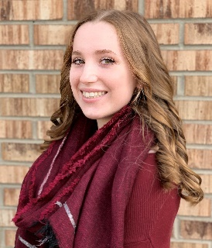
Hannah Delorto
My hometown is Frankfort, IL, and I graduated from ISU in May with dual degrees in Communication Studies & Economics. I chose to apply to this program because I love the ISU campus and the SoC faculty. I enjoyed nearly every subject area in my COM major, especially political communication. I’ve been working at a local marketing firm for over a year and am also really interested in that field and style of writing! When I’m not on campus, I’m likely to be found writing, fishing, running, or cooking.

Clementina (Tina) Edema
I am from Ondo State in the Southwestern part of Nigeria. I have a bachelor’s degree in Mass Communication and Media Technology from Lead City University, Ibadan. My primary interests are in Organizational Communication, Digital Communication and Public Relations. I have been working for over three years as a sales and marketing manager, and I am heavily invested in communication dynamics, especially when it involves Organizational Communication. I am passionate about volunteering and in my free time I love to read fiction novels. I am also learning how to swim and hope to perfect the butterfly stroke someday!

Michael Escobar
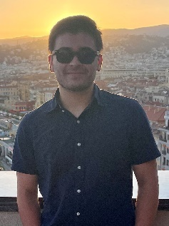
I'm 22 years old, and I'm a resident of Illinois. I moved here when I was about 10. I completed my undergraduate degree at ISU and majored in Interpersonal Communication, which has always been a strong interest of mine since I first started at Heartland Community College. Through my time there, I was able to meet some professors who really shifted my thinking about day-to-day communication. Whether through the media we consume every day or the natural conversations we engage in with peers and strangers, I've always loved analyzing the mechanics of each medium. With this mindset, I decided to take a leap and pursue further education to see for myself what this field of study has to offer. ISU was the perfect match for me because I believe they have the strongest School of Communication, and many of the professors I have met here are incredibly knowledgeable about any topic you throw at them.

Emmanuella (Ella) Ama Gyamfi
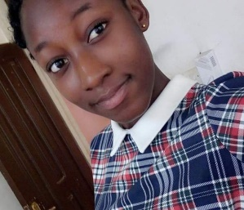
I am from the Central Region of Ghana. I graduated from the University of Cape Coast in 2021 with a Bachelor’s degree in communication studies. I am passionate about communication, especially public relations because I believe it plays an essential role in the growth of any organisation. And I believe Illinois State University is the best place to pursue this passion because ISU has an excellent school of communication with highly experienced faculty and a well-structured curriculum which places emphasis on practical than theory. Outside of school, I love to watch movies and read. I also enjoy spending time with friends and family.
Joshua (Josh) Haley
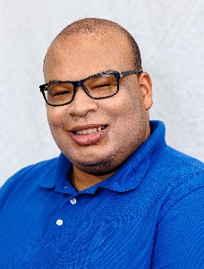
I was born and raised in Chicago and I am returning to ISU after earning my bachelor’s in English Studies last spring! The areas of communication that I am particularly interested in are instructional and mass media! I applied to this program because I enjoy opportunities to share my voice and ideas, as well as help others see the value in good communication skills. Something cool about me is that I’ve been a performer with ISU’s Gamma Phi Circus for the last four years. I primarily perform as a clown, but also help with publicity! I am looking forward to being a part of this program!

Katherine (Kate) Mueller
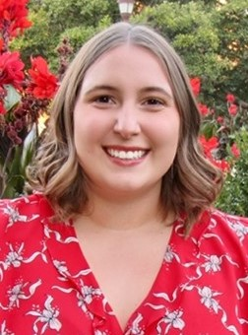
I am from Peoria IL. I just graduated this past spring from ISU with my B.S. in Public Relations and a minor in Civic Engagement. I decided that I wanted to pursue a master’s degree because I enjoy learning and think a masters will help me advance in my professional career. I have an interest in learning more about Interpersonal and Organizational communication. Some of my hobbies include my love for traveling, crafting, going to concerts, and spending time with animals (especially my families two pups Gus and Sadie).

Taylor Murray
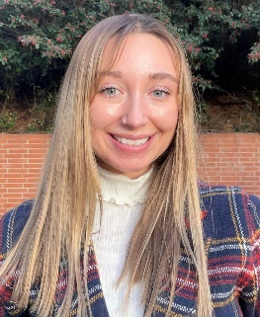
I am from a small town in Illinois called Mount Carroll. I graduated from Illinois State University this past May with a bachelors in Public Relations. My academic interests include public relations, instructional communication and organizational communication. I am pursuing a master’s degree in communication because I have a vested interest in the instruction of communication inside the classroom. In my free time I enjoy attending workout classes, hiking, traveling, spending time with friends and watching tv!

Alina Niftulaeva
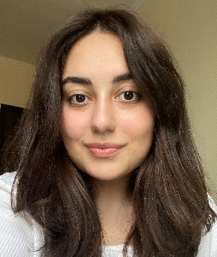
I grew up in Moscow, Russia as a third-culture kid. This experience has led me to discover new things intuitively and with a huge passion for other cultures, which I hope to fulfill at ISU with such a giant and vibrant community. I earned my bachelor's degree with honors in Translation studies from the Moscow State Pedagogical University. Also, I worked as a journalist, reporter, SMM editor, and assistant at the largest media companies in Russia. My areas of interest are the Influence of mass media, public communication, and more. My love for the ISU COM was instant and I can't wait to start the journey! In my free time, I like to explore the world of movies and TV series, learn languages, and try new hobbies.

Edikan Nkanta
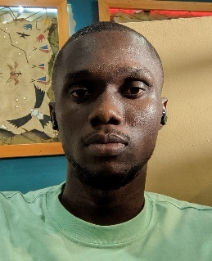
I am from Akwa-Ibom state in the Southern part of Nigeria. I graduated from the University of Lagos in 2018 with a Bachelor’s degree in Mass Communication. I have worked in marketing, communications, and sales over the course of my career. As someone who has worked at companies with poor communication, I am primarily interested in organizational communication and how businesses can effectively communicate with both internal and external stakeholders. I applied to ISU because of the profile of the faculty members and the wide range of topics in the curriculum. In my free time, I love to produce music and watch sports.

Clifford Opare Addo
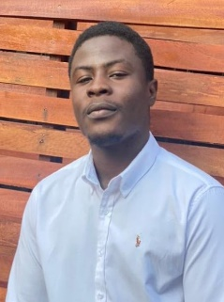
I am from Ghana, born in a city called Kumasi. I graduated with a first class honors degree Communication Studies from Ghana’s premium university, Kwame Nkrumah University of Science and Technology (KNUST). I am looking forward to improve my knowledge of Public Relations (PR), but also broaden my knowledge in the fields of Media Studies, Interpersonal Communication, Environmental Communication, Mass Communication and Sustainability, among others. My ultimate goal is to be conducting research, preparing scholarly publications and promoting research within the Communication community.

Devin Powell
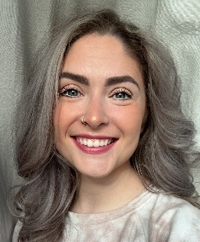
I’m originally from Ann Arbor, Michigan but have spent most of my life in Bloomington/Normal and received my B.S. in Interpersonal Com from ISU. I chose the Master’s program at ISU because they have one of the best com programs around, and the curriculum will allow me to have flexibility as a mom and full-time employee at Rivian Automotive as an Account Manager. When I’m not studying or working, I love spending time with my daughter, husband, our two cats and dog.

Charlie Pujol
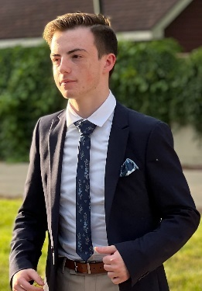
I’m from Orland Park, Illinois. I went to ISU the last four years for my undergraduate degree in mass media. I love the interactive mass media side of communication (video editing, filming, social media, etc.). I applied for the program to not only continue my practices and learn even more about the field I love, but to also teach some incoming students about some of the basics of what I learned and what I love to do! ISU is like a second home to me and I can’t wait to finish strong these next two years.

Alexis Quick
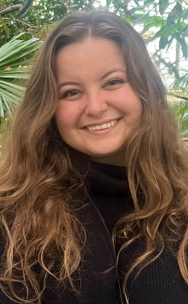
I’m from Valparaiso, IN. I am a recent graduate of Manchester University where I received my B.S. in Marketing and Business Management with a minor in Public Relations. My primary areas of interest are in Public Relations and Organizational Communication. During undergraduate research, I enjoyed finding connections between communication and legal matters, and my undergraduate thesis investigated the media’s effect on U.S. tort reform. I plan to eventually receive my doctorate and one day become a professor. Outside of school, I am most often found drinking coffee and tending to my many plants.

Haley Roiland
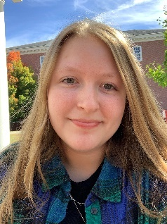
I am from Lake Zurich, Illinois. I graduated from Illinois State University in May with a B.S. in Public Relations and a minor in Spanish. I loved my time as an undergrad at ISU and in the School of Communication so much, that I wanted to stay at ISU for my masters. The discipline I am most interested in, currently, is Public Relations. During my undergrad, I spent a significant amount of my time at the radio station on campus, WZND. As a result, you can find me in my free time listening to the radio whether that’s 103.3 WZND, 101.9 The Mix, or some other station. I also enjoy going for walks around town, listening to music, going to the movies, baking, and even scrapbooking.

Makayla Roller
I lived in a small town called Abingdon, IL for most of my life but made the move to Peoria, IL to attend Bradley University when I graduated high school. I studied Public Relations and Advertising in my undergraduate degree but found that I was really passionate about interpersonal and mass media studies. As graduation approached, I knew I wanted to continue to explore those topics and I started to see a future in teaching. Illinois State came into the picture because I have always thrived in smaller, more collaborative environments. I also had many trusted professors who spoke so highly of the program, and after that, it was apparent that Bloomington-Normal would become my new home.

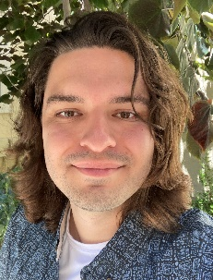
David Valadez
I am a graduate of California State University, East Bay and a native of Pleasanton, California. My interest and specialty within the field of Communication lies in the areas of Rhetoric and Persuasion generally, and Speech Forensics in particular. I was drawn to Illinois State University by its exceptional Forensics program. I look forward to studying with the Graduate Program and writing as many stupid jokes for the Forensics team as possible.

Miriam Wolff
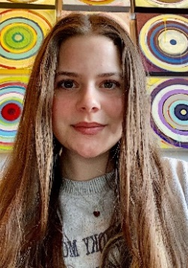
I am from Bunker Hill, IL. I received a bachelor’s degree in Interpersonal Communication in May ‘23 at Illinois State and I am excited to continue my journey here at a place I call home. During my time at ISU, I discovered quickly that interpersonal and intercultural communication work together to satisfy my desires to seek deeper human connections. I applied to this program because the School of Communication has not only given me priceless relationships with my professors and peers, but the tools to live a full life pursuing a study I am deeply excited for. In my free time I enjoy reading, writing, watching films, and spending time with the people I love.

Raechel Zoellick (she/her)
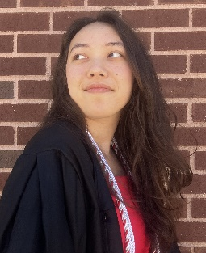
I’m from Elk Grove Village, IL. I transferred to ISU in January 2022 to compete for the speech team and graduated from the school in May 2023 with a degree in Statistics and a minor in music. I applied to the program to work with ISU’s speech team and am excited to study and apply as many areas of communication as possible during my time here. In my free time, I love listening to and creating music, building my book and board game collections, and finding the best boba places around (ask me for my tier list).

